Gait Phase Classification: A Deep Learning Approach

Ponkoj Chandra Shill
Computer Science and Engineering
University of Nevada, Reno, USA
pshill@unr.edu

Computer Science and Engineering
University of Nevada, Reno, USA

Abstract— The classification of gait is essential for diagnosing gait disorders, specifically in older adults. Traditional gait classification methods that rely on videos often encounter high latency and challenges with low frame-rate inputs. Our research investigates the efficacy of two deep learning models, ResNet152V2 and InceptionV3, for the classification of gait phases using the CASIA Gait Database. Both models, pre-trained on ImageNet and enhanced with tailored layers, were assessed using datasets for training and validation. Our methodology utilizes single-image frames for gait classification, which dramatically decreases latency while preserving accuracy. It offers a low-latency alternative to video-based methods.
Keywords— gait, neural network, resnet, inception.
- Introduction
The prevalence of gait disorders is increasing, with more than three-fifths of community-dwelling individuals aged 80 years and older experiencing this issue. Common neurological causes include sensory ataxia, parkinsonism, and frontal gait disorders, while hip and knee osteoarthritis are common non-neurological causes. As people age, they are more likely to have multiple or combined causes of gait disorders [1].
This increases the need to understand and diagnose gait abnormalities effectively. Gait refers to the pattern of limb movements during walking or running. Everyone has a unique walking pattern, and changes to that pattern lead to an abnormal gait pattern. To detect these patterns, gait classification comes into play. It is vital to understand a gait cycle, and the classification.
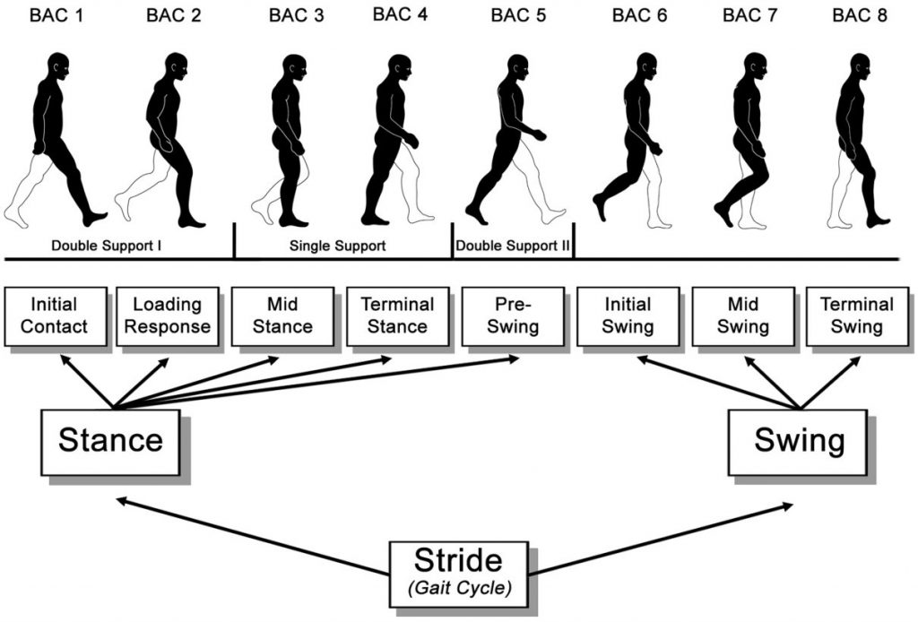
Figure 1: This diagram displays all 8 subphases, and the major phases' stance and swing of a gait cycle.
The gait cycle begins when one-foot contacts the ground and ends when that foot contacts the ground again. In this cyclical pattern, the stance phase involves the limb's contact with the ground, while the swing phase represents the period when the limb is elevated. The stance phase accounts for approximately 60% of a single gait cycle, and the swing phase occupies approximately 40%.
This diagram defines the gait cycle, showing the difference between the stance and swing phases. The stance phase occurs when the foot is in contact with the ground and consists of five subphases. The swing phase begins when the foot leaves the ground and has three subphases. The dataset used to train the model consists of frames of people walking from various angles, covering all subphases of the action.
Through manual labelling of these frames into the major phases, such as stance and swing, I have prepared the data and trained two different neural network models. This approach allows for faster processing and ensures accurate classification across diverse angles and conditions. By leveraging neural networks trained on varied angles of the gait cycle, this methodology aims to make gait diagnostics more accessible. It offers clinicians a versatile and cost-effective tool that can significantly enhance diagnosis, rehabilitation, and treatment across the globe.

Traditional gait analysis methods often rely on high-frame-rate video input, which can lead to high latency and inefficiencies in real-time applications. In contrast, this work introduces a single-image-based deep learning approach that minimizes latency while maintaining accuracy.
The primary contributions of this work include:
- Novel single-frame gait classification approach reducing computational latency.
- Comparative analysis of deep learning architectures (ResNet152V2 vs. InceptionV3).
- Performance evaluation with accuracy, precision, recall, and F1-score.

- Background
The rising prevalence of gait disorders, especially in older adults, accentuates the pressing need to develop efficient and effective gait classification methodologies. Gait classification is of profound importance not only in healthcare but also in various applications, ranging from steering robotic exoskeletons used in rehabilitation to optimizing athletic performance through improved biomechanical analysis. By classifying gait patterns, healthcare professionals can tailor treatment plans that expedite recovery in patients with gait impairments. Additionally, it assists in refining athletic movements, reducing the risk of injuries, and enhancing overall sports performance.
Conventional video-based gait recognition methods, despite their inclusiveness, are often hindered by high latency and underperform with low frame-rate inputs. This project seeks to revolutionize gait recognition by leveraging single-image frames for training.
This project aims to solve key issues in gait classification by focusing on accurate identification from single-frame images. By reducing reliance on high frame-rate video data, we aim to improve classification accuracy across diverse datasets while significantly minimizing latency. This enables faster diagnostic insights and increases applications where we would need lower latency.
- Related Work
Gait classification has evolved significantly, with recent deep learning advancements improving accuracy and efficiency.
Pirker and Katzenschlager (2017) provided a clinical perspective on gait disorders and highlighted the need for automated recognition methods [1]. Recent works have explored deep learning-based gait analysis using various methodologies.
One of the fundamental challenges in gait classification is the reliance on high-frame-rate videos, which can introduce latency and inefficiencies in real-time applications. To address this, Al-Huseiny et al. (2010) developed a gait learning-based regenerative model using a level-set approach [2]. However, their approach required temporal interpolation, making it less effective for low-frame-rate or single-image classification.
In the field of gait recognition, capturing full gait cycles using video sequences has been the traditional approach. However, this method presents a challenge, as capturing complete gait cycles can be time-consuming, resulting in latency issues for real-time recognition. To overcome this limitation, researchers have sought alternative ways to enhance recognition performance with limited data, such as low frame-rate videos or even single images.
Guan et al. (2013) attempted to resolve these issues by introducing a metric learning-based gait recognition method, which extracted gait features from extremely low-frame-rate videos [3]. While effective in reducing dependency on high-frame-rate sequences, their model struggled with generalization when presented with sparse gait data.

Xu et al. (2021) introduced PA-GCRNet, a deep learning model that reconstructs the gait cycle from a single image using a phase estimator before classification [4]. Our approach differs in that it does not require gait cycle reconstruction but instead directly classifies gait phases from static frames, offering lower latency and real-time applicability.

Existing methods include temporal interpolation and super-resolution-based approaches, metric learning-based approaches, and gait feature reconstruction-based approaches. Al-Huseiny et al. (2010) introduced a gait learning-based regenerative model using a level-set approach to handle temporal interpolation. The proposed framework reconstructs a set of gait cycles using Principal Component Analysis (PCA) to model shape deformations. This is ineffective for very low frame rates or single-frame inputs due to reliance on temporal information for interpolation[2]. Another approach is the metric learning approach. Guan et al. (2013) applied a random subspace method (RSM) to reduce errors arising from low frame-rate inputs. They extracted gait features by averaging sequences and directly applied metric learning to low frame-rate videos. The approach struggles with extremely low frame rates (e.g., 1 fps) due to the challenge of finding robust subspaces with good generalization occurs for very few input frames. Recently, C. Xu et al. proposed PA-GCRNet for gait recognition using a single image. It reconstructs the full gait cycle with a phase estimator and feeds this into a recognition network like GaitSet for matching[4]. In our approach, we experiment with different models to classify between stance and swing.
- Approach
- Dataset Collection
For gait recognition research, the CASIA Gait Database includes four datasets: A (video, 20 subjects, three angles), B (multiview video, 124 subjects, 11 angles), C (infrared, 153 subjects, four conditions), and D (video and Rscan Footscan, 88 subjects).
- Data Cleaning
For improved training, manually curated about 5000 images from an initial pool of 19000 in datasets A and C.
- Dataset Labeling
To train the model, it was essential to manually label the complete dataset into two categories: stance and swing. The dataset consisted of frames from eight different classes as well as frames that could not be visually identified.
- Test- Train Split:
The data set had been split into training and validation, with a ratio of 80:20.
- Model Selection & Training
In order to leverage pre-trained ImageNet features, ResNet152V2 and InceptionV3 were chosen as the two models for this task.
Model Architecture
We employ ResNet152V2 and InceptionV3, pre-trained on ImageNet, with the following modifications:
- Dropout layers (rate: 0.5) to prevent overfitting.
- Dense layers (128 → 12 neurons) with ReLU activation.
- Softmax output for binary classification.
- Nadam optimizer (learning rate: 0.001).

Both models exhibit similar structures in terms of their custom layers and parameters. To achieve efficient weight adjustments, the Nadam optimizer with a learning rate of 0.001 was employed for both models. In both architectures, the base models (with set to ) retain their learned ImageNet features, while all layers are frozen to preserve this knowledge.
Each model incorporates a dropout layer following the base model to overcome overfitting. Flatten layers convert extracted features into a one-dimensional array for processing by dense layers. These dense layers begin with 128 neurons and progressively decrease to 64, 48, 36, 24, and finally 12 neurons. Dropout layers are placed between each dense layer to enhance generalization and prevent overfitting. Both models employ a final Softmax activation layer to classify gait phases.

Training Strategy:
- Early Stopping was applied to halt training upon validation accuracy stagnation.
- Batch normalization was implemented to improve generalization.

EarlyStopping callbacks are configured similarly, monitoring validation accuracy and stopping training early when improvements stall. This setup ensures efficient training while reducing overfitting and getting the best weights for the nodes. Using batch normalization, dropout layers, and optimized learning rates together gives both models strong classification performance, which lets them correctly identify gait phases.
- Evaluation
The provided training versus validation loss and accuracy graphs are a good way to look at how well the ResNet152V2 and InceptionV3 models train.

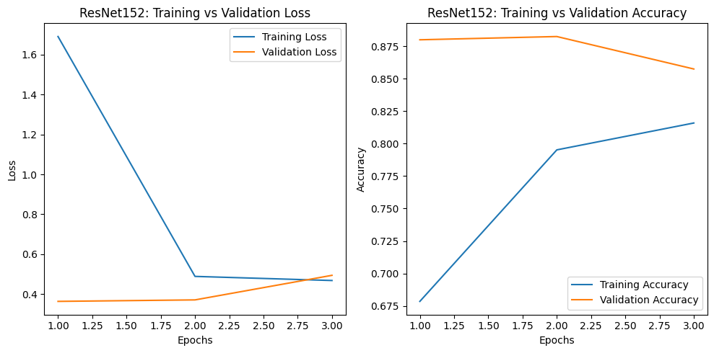
Figure 2: The first plot plots the loss and the second plot plots the accuracy for ResNet152V2.

The ResNet152V2 model exhibits a significant initial reduction in training loss, stabilizing at a lower level as the epochs progress. A similar downward trend is observed in validation loss, albeit with less fluctuation, suggesting effective model generalization without severe overfitting. The accuracy graph reveals a steady improvement in both training and validation accuracy, with validation accuracy reaching a maximum of 88.00% with before early stopping at the third epoch due to marginal gains. This close alignment between training and validation accuracy indicates that the model effectively extracts generalized features from the dataset.
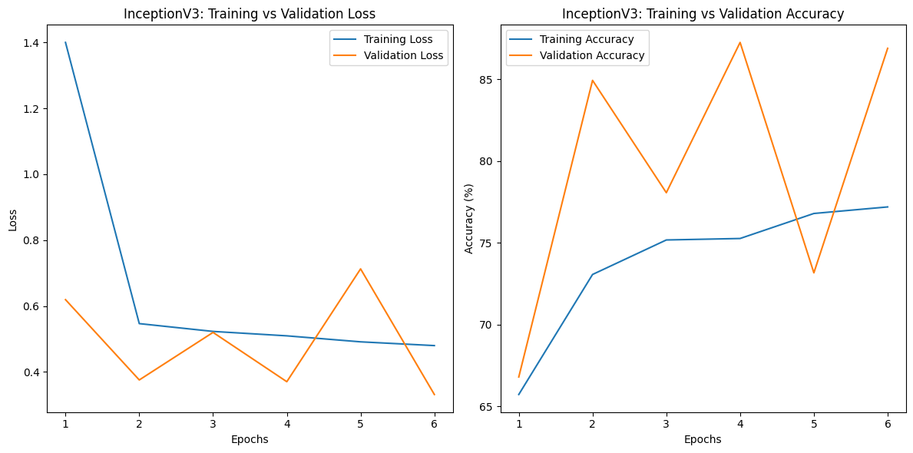
Figure 3: The first plot plots the loss and the second plot plots the accuracy for InceptionV3
.
In comparison, the InceptionV3 model reveals more significant variations in its validation loss and accuracy metrics. While the training loss initially reduces notably, the validation loss experiences significant fluctuations, indicating potential difficulties with model generalization. The validation accuracy graph showcases substantial variability, achieving a peak of 87.25% during the fourth epoch. While the accuracy of training usually goes up, the fact that the accuracy of validation goes up and down suggests that more tuning may be needed to make the model more stable across different epochs and make it more robust overall.

The ResNet152V2 model displayed superior stability and achieved higher validation accuracy at an earlier stage compared to the InceptionV3 model. This stability makes ResNet152V2 a more dependable option for this specific application. However, the peak performance of InceptionV3 indicated its potential for improvement with further optimization. To enhance InceptionV3’s consistency and overall performance, future endeavors could investigate additional regularization techniques or conduct hyperparameter tuning.

Performance Metrics
We evaluated the models using accuracy, precision, recall, and F1-score.

Model | Accuracy | Precision | Recall | F1-score
ResNet152V2 | 88.0% | 87.5% | 86.8% | 87.1%
InceptionV3 | 87.25% | 86.9% | 85.7% | 86.3%

Confusion Matrix Analysis
Analysis of the confusion matrix shows that ResNet152V2 misclassified fewer instances, demonstrating stronger generalization compared to InceptionV3.
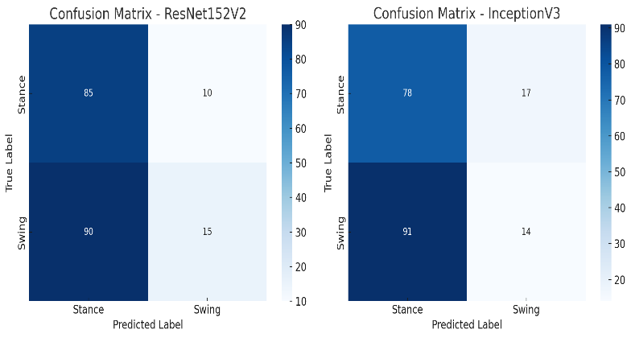
Here are the confusion matrices for both ResNet152V2 and InceptionV3, showing the classification performance for stance and swing phases. Let me know if you need any refinements or further analysis!

Discussion & Limitations
- Strengths:
- Single-frame classification significantly reduces latency.
- Deep learning surpasses traditional video-based approaches in efficiency and accuracy.
- Potential for real-time gait disorder diagnosis in healthcare and rehabilitation.
- Limitations:
- Manual annotation introduces potential bias – future work should automate this process.
- Limited dataset diversity – incorporating real-world patient data would improve robustness.
- Sensitivity to occlusions – the impact of clothing and accessories remains untested.

- Conclusions & future works
This research demonstrates the effectiveness of deep learning models, specifically ResNet152V2 and InceptionV3, for gait classification using the CASIA Gait Dataset. By leveraging single-image frames instead of traditional video-based approaches, the models significantly reduced latency while maintaining classification accuracy. ResNet152V2 exhibited consistent and stable performance, making it a more reliable choice for gait phase classification. InceptionV3 showed some variability in accuracy but also highlighted the potential for accurate classification with further optimization. Overall, this research provides valuable insights into the application of neural networks for gait classification and paves the way for future developments in the field. For future iterations, we aim to gather a more comprehensive dataset with standardized labeling and potentially include detailed RGB images. Additionally, we plan to enhance our training process by employing robust, pre-trained models, with the objective of improving accuracy with the extension of classifying all possible gait classes.

This study confirms that deep learning-based single-frame gait classification is a viable low-latency alternative to video-based methods. ResNet152V2 demonstrated superior stability, while InceptionV3 exhibited potential for optimization.
- Future Directions:
- Expand dataset to include diverse walking conditions and occlusions.
- Improve model robustness through domain adaptation techniques.
- Deploy real-time inference on mobile and embedded systems for clinical applications.

References
- R. Pirker and F. Katzenschlager, "Gait disorders in adults and the elderly: A clinical guide," Wiener Klinische Wochenschrift, vol. 129, no. 3–4, pp. 81–95, Feb. 2017. [Online]. Available: https://doi.org/10.1007/s00508-016-1096-4
- M. S. Al-Huseiny, S. Mahmoodi, and M. S. Nixon, "Gait learning-based regenerative model: A level set approach," Proceedings of the 20th International Conference on Pattern Recognition, Istanbul, Turkey, Aug. 2010, pp. 2644–2647.
- Y. Guan, C. T. Li, and S. Choudhury, "Robust gait recognition from extremely low frame-rate videos," 2013 International Workshop on Biometrics and Forensics (IWBF), Lisbon, Portugal, Apr. 2013, pp. 1–4. DOI: 10.1109/IWBF.2013.6547319.
- C. Xu, Y. Makihara, X. Li, Y. Yagi, and J. Lu, "Gait Recognition from a Single Image using a Phase-Aware Gait Cycle Reconstruction Network," in Proc. IEEE Int. Conf. on Biometrics Theory, Applications and Systems (BTAS), Nanjing, China, September 2021, pp. 1-8.
- [1] R. Pirker and F. Katzenschlager, "Gait disorders in adults and the elderly: A clinical guide," Wiener Klinische Wochenschrift, 2017.
[2] M. S. Al-Huseiny et al., "Gait learning-based regenerative model: A level set approach," ICPR, 2010.
[3] Y. Guan et al., "Robust gait recognition from extremely low frame-rate videos," IWBF, 2013.
[4] C. Xu et al., "Gait Recognition from a Single Image using PA-GCRNet," BTAS, 2021.

